

**Integrating with Identity Provider**

Keycloak can be Integrated with Identity Providers like Google, Facebook, Instagram .,etc

Here we are integrating Github with keycloak, so that who have Github accounts can use that account to login into keycloak or access applications which they are permitted to do.

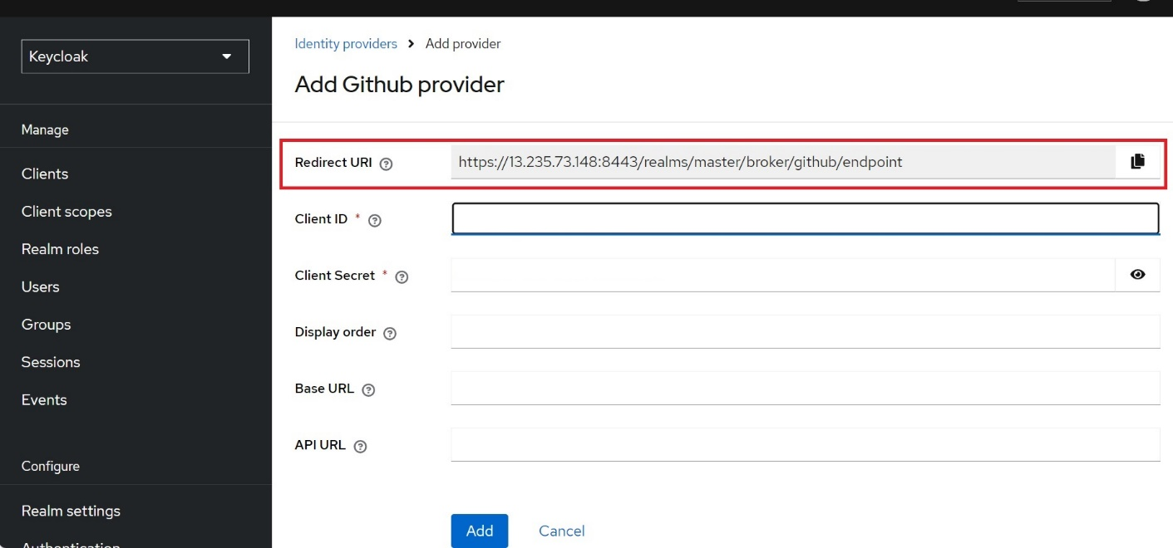

Paste the redirect url and account console url in Github OAuth app registration in Homepage URL and Authorization Callback Url respectively for creating the OAuth app in github as in below image.

Then register the application and generate the Client secret.

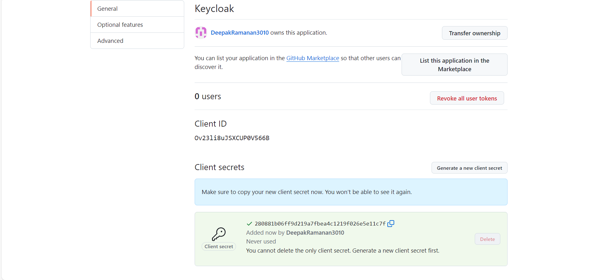

Now copy and paste both the client and client secret in keycloak and add the identity provider in keycloak.

After adding the identity provider we can use the github user account to login keycloak.

After authorizing the user to login keycloak that user details also added to keycloak as in below image.

In above Image “deepakramanan3010” is the user added to keycloak through github, later this user can also be used like other user in the keycloak .